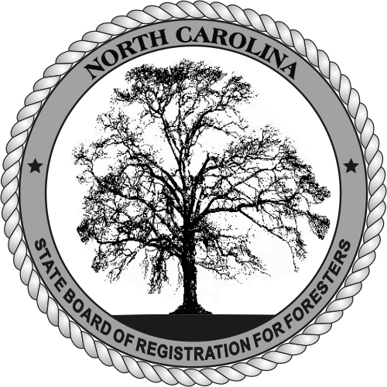
STATE BOARD OF REGISTRATION FOR FORESTERS

POST OFFICE BOX 27393
RALEIGH, NORTH CAROLINA 27611
PHONE: 919-847-5441

WEB PAGE: NCBRF.ORG
E-MAIL: INFO@NCBRF.ORG

Request for Verification of Licensure/Registration

To Be Completed by Applicant:
Name: |  | Registration #:

To Be Completed by Responding Board
Our records show the applicant named above:
1. Was registered on (date):
2. Registration Number:
3. Now holds a valid registration which will expire on:
4. Held a valid registration which expired on :
5. Was found to be qualified for registration on the basis of:

 | Written exam: | passing score |  | applicants score

 | Origin of exam: | State |  | SAF CF

Oral exam

 | Education |  | years; and experience of |  | years

 | Comity/Reciprocity with |  | (state)

Grandfather clause in our law

Other (please explain)

Name of Board:
Signed:
Title:
Date:
Address:
Telephone:
Please submit this form to the above address. 7/2011

